BackBase ING solution

**Solution overview**

A web application, which provides a REST API to get list of ING ATMs in a given city, response of this API, will be in JSON format.  
It’s also serve web page for display list of ING ATMs.

**Technologies & Tools used:**

* Spring 3.2.8.RELEASE
* Jersey 2.11
* JDK 1.8
* Maven 3.3.3
* Tomcat 8
* Intellij IDEA 14.1.1
* Log4j
* JUnit
* AngulerJS

How to Test

This application packaged as a WAR.

To build WAR file, run the maven command: **mvn clean install**

Deploy generated war file in apache tomcat server.

OR

To generate WAR file and deploy on tomcat server you can use eclipse or Intelliij IDE.

After successful deployment on server you can execute APIs by using any rest client (e.g Postman)

**REST web service**

API URL to get ING ATMs by city

|  |
| --- |
| http://localhost:8080/rest/ing/<cityName> |

Following are the screenshot for same.

Before calling API

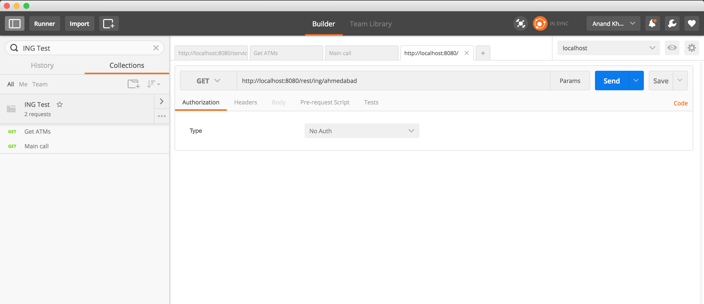

After calling API

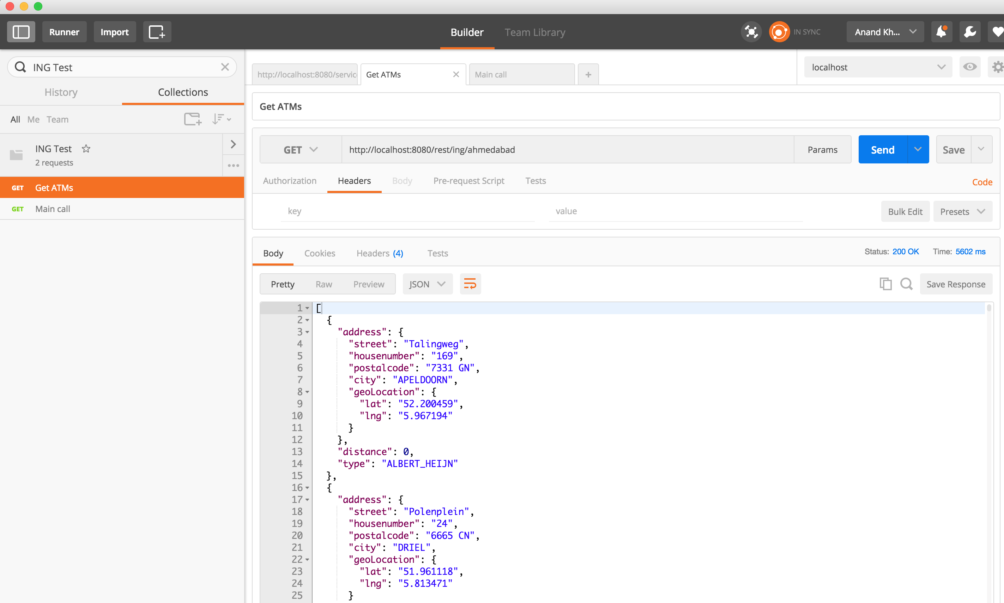

**Front-End**

URL : <http://localhost:8080/>

Asking for city name.

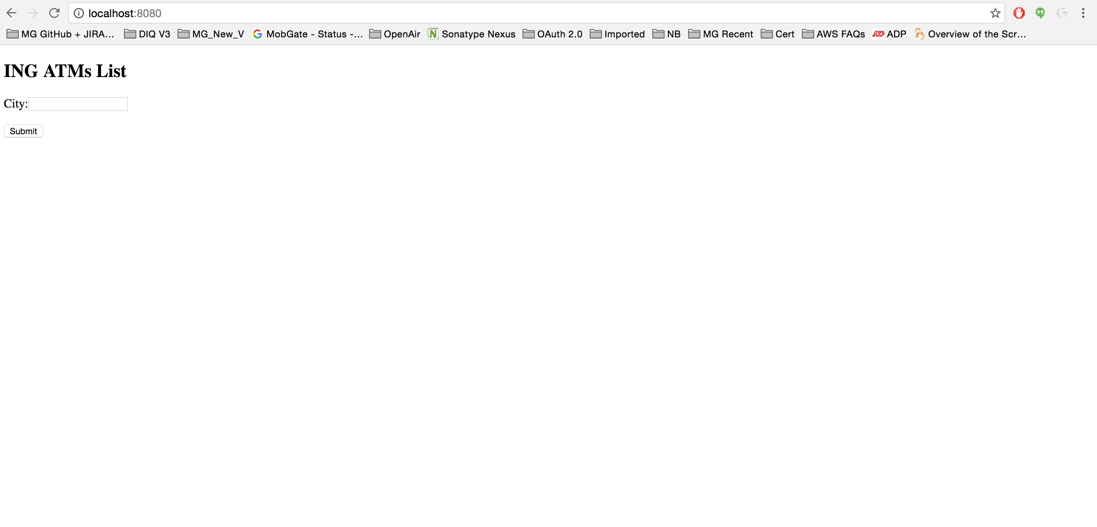

Applied validation on city field, validation message will be display in case of empty.

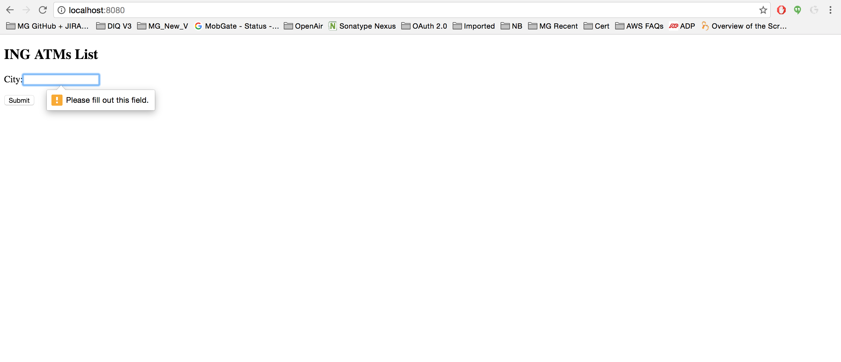

Display street and city of the ATMs.

